**National University of Computer and Emerging Sciences**



**Lab Manual 09**

**Object Oriented Programming**

|  |  |
| --- | --- |
| Course Instructor | Ms. Syeda Tayyaba Bukhari |
| Lab Instructor (s) | Ms. Fariha Maqbool  Mr. Muhammad Usama Alam |
| Section | BCS-2H |
| Semester | Spring 2023 |

Department of Computer Science

FAST-NU, Lahore, Pakistan

## **Objectives**

After performing this lab, students will practice:

* Inheritance (Multilevel, Multiple)
* Function overloading, overriding

# **TASK 1: (Multilevel Inheritance)**

**Exercise 1:**

Consider the following hierarchy as it exists in a university:

* There is only one type of person in the university i.e. Student.
* Every Person has some basic information that is common to all persons i.e. the name (a character array), ID and age stored as attributes.
* A student can in turn be either an Undergraduate or a Graduate student, every student has a cgpa and rollNumber.
* An undergraduate student has a fyp_name as his private attribute.
* A graduate student has a thesis topic and supervisor name as his private attribute.

**Exercise 2:**

**1**. Add appropriate **constructors** and **destructors** to all the classes. For example, the constructor for the Person class should take three inputs (*ID*, first_name, last_name and age).

* Print “In constructor of class x” and “In Destructor of class x” in constructors and destructors.

**2a**. Add a member function, **void print()** in the Person class that prints name of person.

**2b**. Add a member function, **void print()** in the Student class. This method should print the name, cgpa and age of the student.

**Sample output:** “Ted Thompson is 22 years old, his cgpa is 3.91”

**2c**. Add a member function **void print()** in the Graduate class. This method should print the name, cgpa and age of the student, his thesis topic and supervisor’s name.

**Sample output for void print():** “Ted Thompson is a graduate student, his cgpa is 3.91 and his thesis topic is Distributed Algorithms under supervision of Dr. Kashif Zafar”

**2d**. Add a member function **void print()** in the UnderGraduate class. This method should print the name, cgpa and age of the student and his fyp_name.

**Sample output for void print():** “Ted Thompson is an undergraduate student, his cgpa is 3.91 and his final year project is titled The Even Locator”

**3a**. Add a member function, **void input()** in the Student class. This method should take input in ID, name, cgpa rollNumber and age of the student.

**3b**. Add a member function **void input()** in the Graduate class. This method should take input in thesis topic, supervisor’s name.

**3c**. Add a member function **void input()** in the UnderGraduate class. This method should take input in fyp_name.

**Exercise 3:**

Implement this main function:

1. Create two objects UnderGraduate and Graduate class individually.
2. Call the input function to take input in the data from user.
3. Create two pointers of class Student which will hold two objects of UnderGraduate and Graduate class. Call Input and Print functions.
4. Create a pointer of Person class which will hold an object from UnderGraduate/Graduate class (upon your wish). Call Print Function. Notice the output. How would you justify this behavior?

//example main function

void main()

{

//format (ID, fName, lName, Age, RollNumber, cgpa, fyp/thesis)

Student * s = new Undergraduate(1,"Ted”, T”hompson",22, “14L-4171”, 3.91,"The Event Locator");

Student * s2 = new Graduate(2,"Arnold”, “Gates",25, “17L-6171” 3.01,"Distributed Algorithms");

s->print();

s->input();

s2->print();

s2->print();

s->print();

s2->print();

}

# **TASK 2: (Multiple Inheritance)**

In this exercise, we are working with the following classes to implement multiple inheritance: **Shape, Painting, Square, Rectangle,** and **Triangle.**

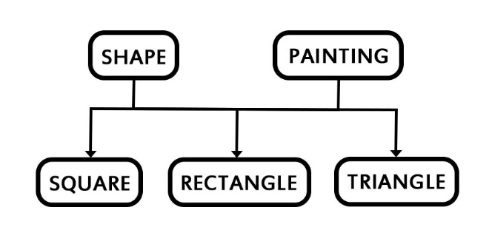Implement the class hierarchy given below:

1. Class **Shape** has following protected data members: **length, breadth, height.**
2. Class **Square, Rectangle,** and **Triangle** all have **getArea()** method.
   1. Area of square = length * lenth
   2. Area of rectangle = length* breadth
   3. Area of triangle = ½ * breadth * height
3. Class **Painting** has method **getCost(area)** which returns the cost of painting a shape by multiplying paint cost with area of the shape.
4. For simplicity, you only create **one .h** file which contains the headers of all classes and **one .cpp** file which contains the implementation of all classes. Also, you are not required to use polymorphism in this question
5. Consider the following output(You can input your own values):

